DATABASE SYSTEM DCI2033
SEMESTER I, ACADEMIC YEAR 2011/2012

Labsheet 1

- Write your SQL command for each question.
- Create a table to store the patient information. The table should content patient number, name, address and date of birth. Assign suitable data types.
CREATE TABLE PATIENT
(PAT_NUM NUMBER,
PAT_NAME VARCHAR2(30),
PAT_ADDRESS VARCHAR2(40),
PAT_DATEOFBIRTH DATE);
- Insert all the data for the above table.
INSERT INTO patient VALUES
('123','Zana','Melaka','23 January 1994');
- Drop the patient information table.
DELETE FROM patient WHERE PAT_NUM='123'

- Answer all the questions below:

Name | DataType
------------------------------------------------------------------------------------
STD_NAME | VARCHAR2 (20)
STD_ID | VARCHAR2 (8)
STD_IC | NUMBER
STD_COURSE | VARCHAR2 (30)
STD_DATEOFBIRTH | DATE
STD_ADDRESS | VARCHAR2 (40)

- In your database create a table called STUDENTS_INFO based on the table above.
CREATE TABLE STUDENTS_INFO
(STD_NAME VARCHAR2(20),
STD_ID VARCHAR2(8),
STD_IC NUMBER,
STD_COURSE VARCHAR2(30),
STD_DATEOFBIRTH DATE,
STD_ADDRESS VARCHAR2(40));
- Drop the date of birth column from STUDENT_INFO table and show the SQL command.
alter table "STUDENTS_INFO" DROP COLUMN
STD_DATEOFBIRTH
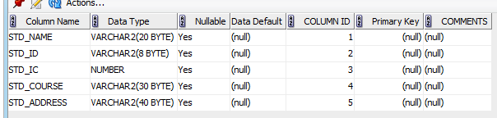

- Drop the address column from STUDENT_INFO table and show the SQL command.
alter table "STUDENTS_INFO" DROP COLUMN
STD_ADDRESS
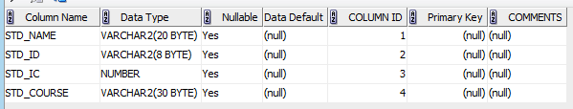
- Shows the SQL command to add the date of birth column on the STUDENT_INFO table.
alter table "STUDENTS_INFO" ADD
(STD_DATEOFBIRTH DATE NULL);
- Shows the SQL command to add the address column on the STUDENT_INFO table.
alter table "STUDENTS_INFO" ADD
(STD_ADDRESS VARCHAR2(40) NULL);

